**HTTPS For provider**

**SSL=secure socket layer**

**If we want transfer data securely over internet in that case implement this.**

**Do this only if any one asks us to do https**

**Applicable only for HTTP and SOAP nodes**

If applications listening at eg port (that is 7800,7801 etc) then this step will work other wise will not work use

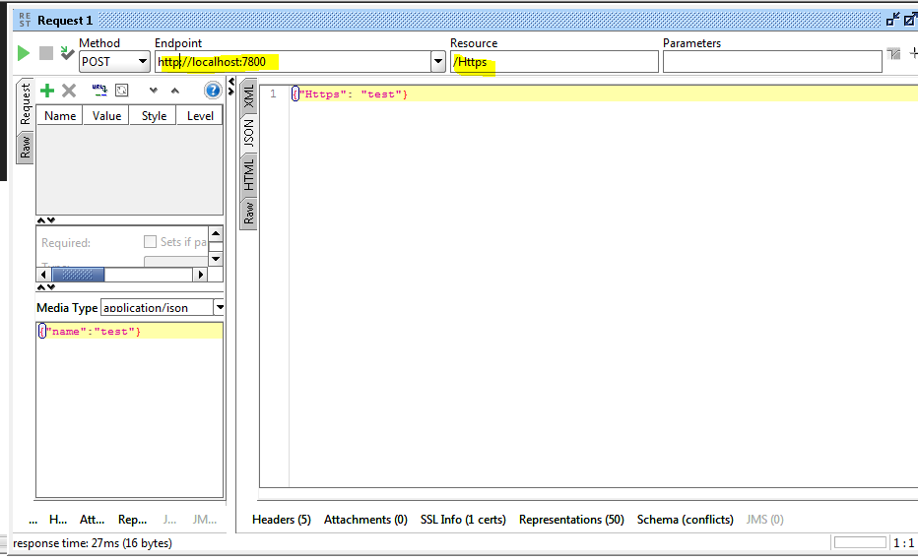

1)First check port number (Initially it will be zero)

**mqsireportproperties TEST -e default -o HTTPSConnector -n port**

2)Give any port number between 7843 – 7884

(<https://www.ibm.com/mysupport/s/question/0D50z000062k93mCAA/iib-http-port-number#:~:text=The%20default%20range%20for%20the,7801%2C%20and%20so%20on.%22>**)**

**mqsichangeproperties TEST -e default -o HTTPSConnector -n explicitlySetPortNumber -v 7843**

**3)**

Create a folder HTTPs (we can give any name)in C: drive

In console type **ikayman** enter

**ikeyman**

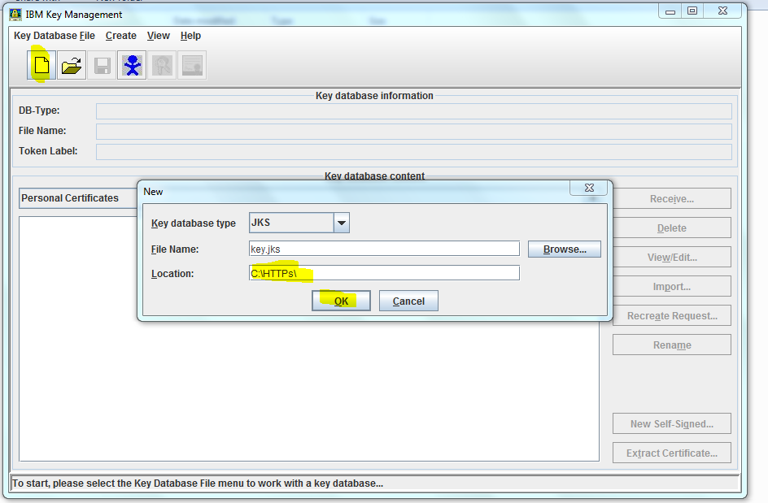

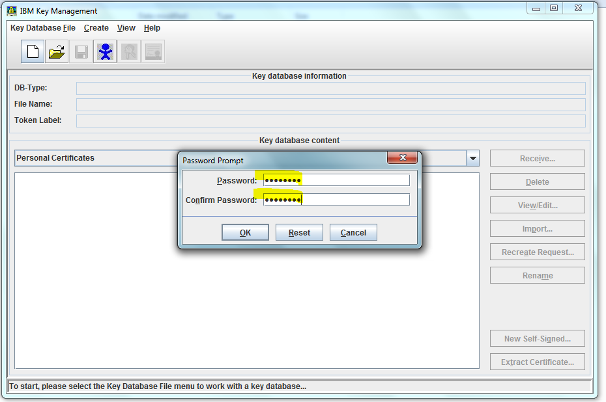

Give any password (remember) click ok

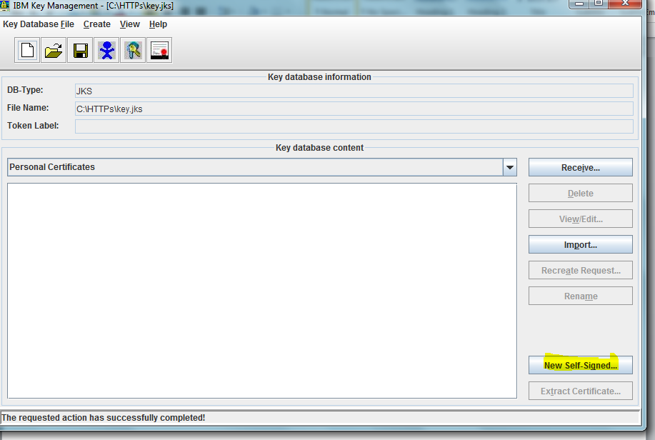

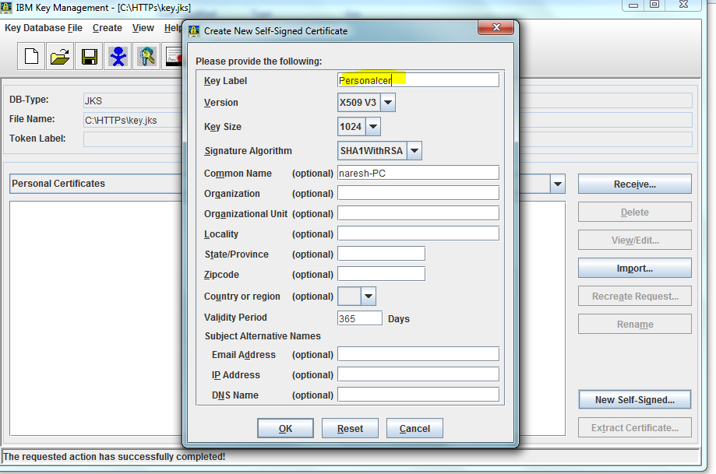

We can give any name in key Lable

We can fill all other fields also

**mqsichangeproperties TEST -e default -o ComIbmJVMManager -n keystoreFile -v C:\HTTPs\key.jks**

**mqsichangeproperties TEST -e default -o ComIbmJVMManager -n keystorePass -v defaultKeystore::password**

In below command use password which we gave in 2nd screen shot

**mqsisetdbparms TEST -n defaultKeystore::password -u ignore -p password**

**stop & stat Node**

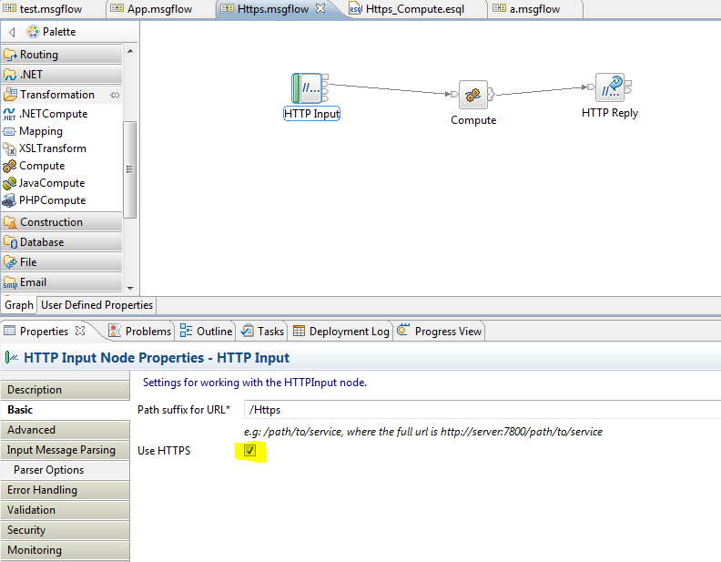

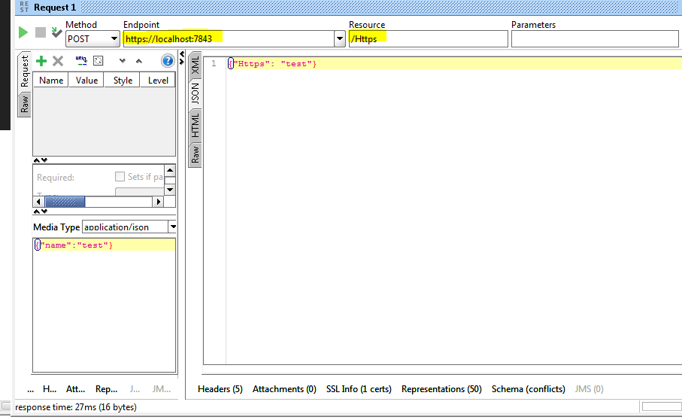

**Put url in browser**

**If u see “Not secure” that means ssl successfull**

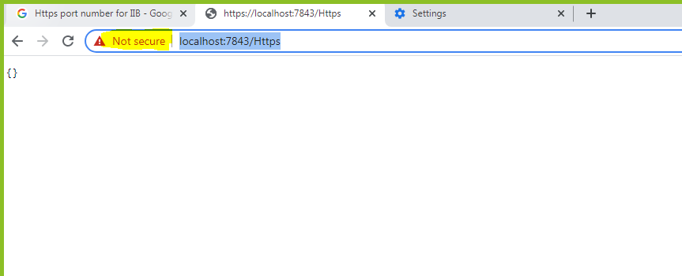

**If we want to make our another application as https in that case just open already created Keystore and generate new certificate**

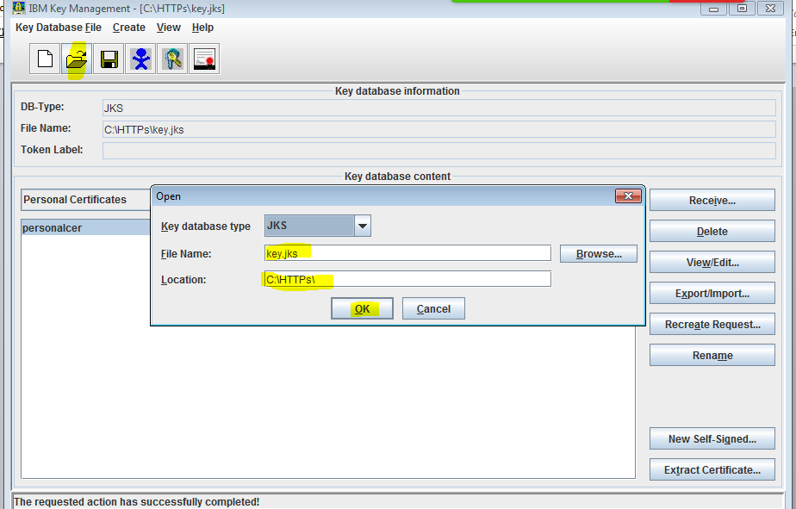





**If required stop & start node**